Poetry Slam | 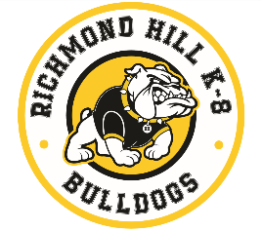
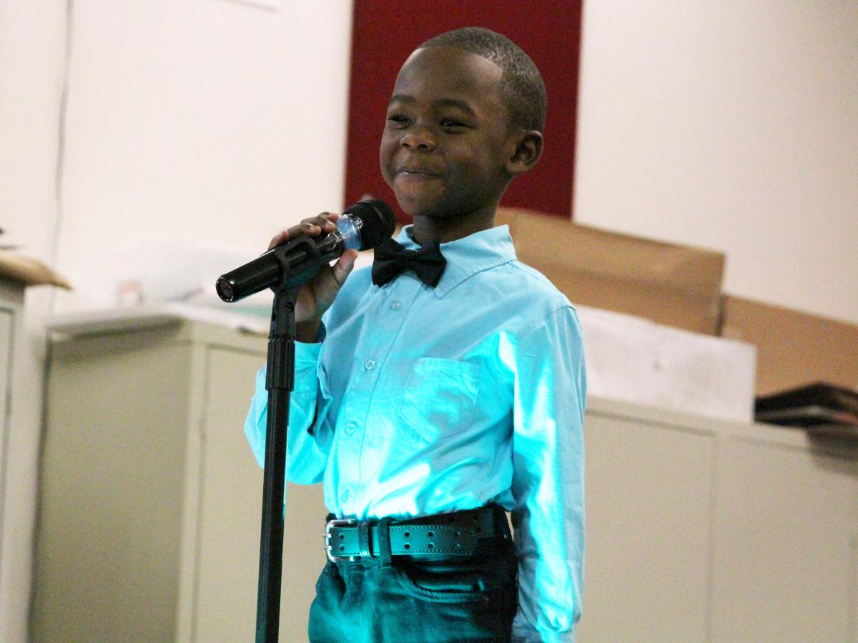  First EVER Richmond Hill K-8 Poetry Slam  ALL STUDENTS, VIRTUAL & FACE-TO-FACE WILL PARTICIPATE  Students will record themselves performing their OWN, original poems to be judged! | 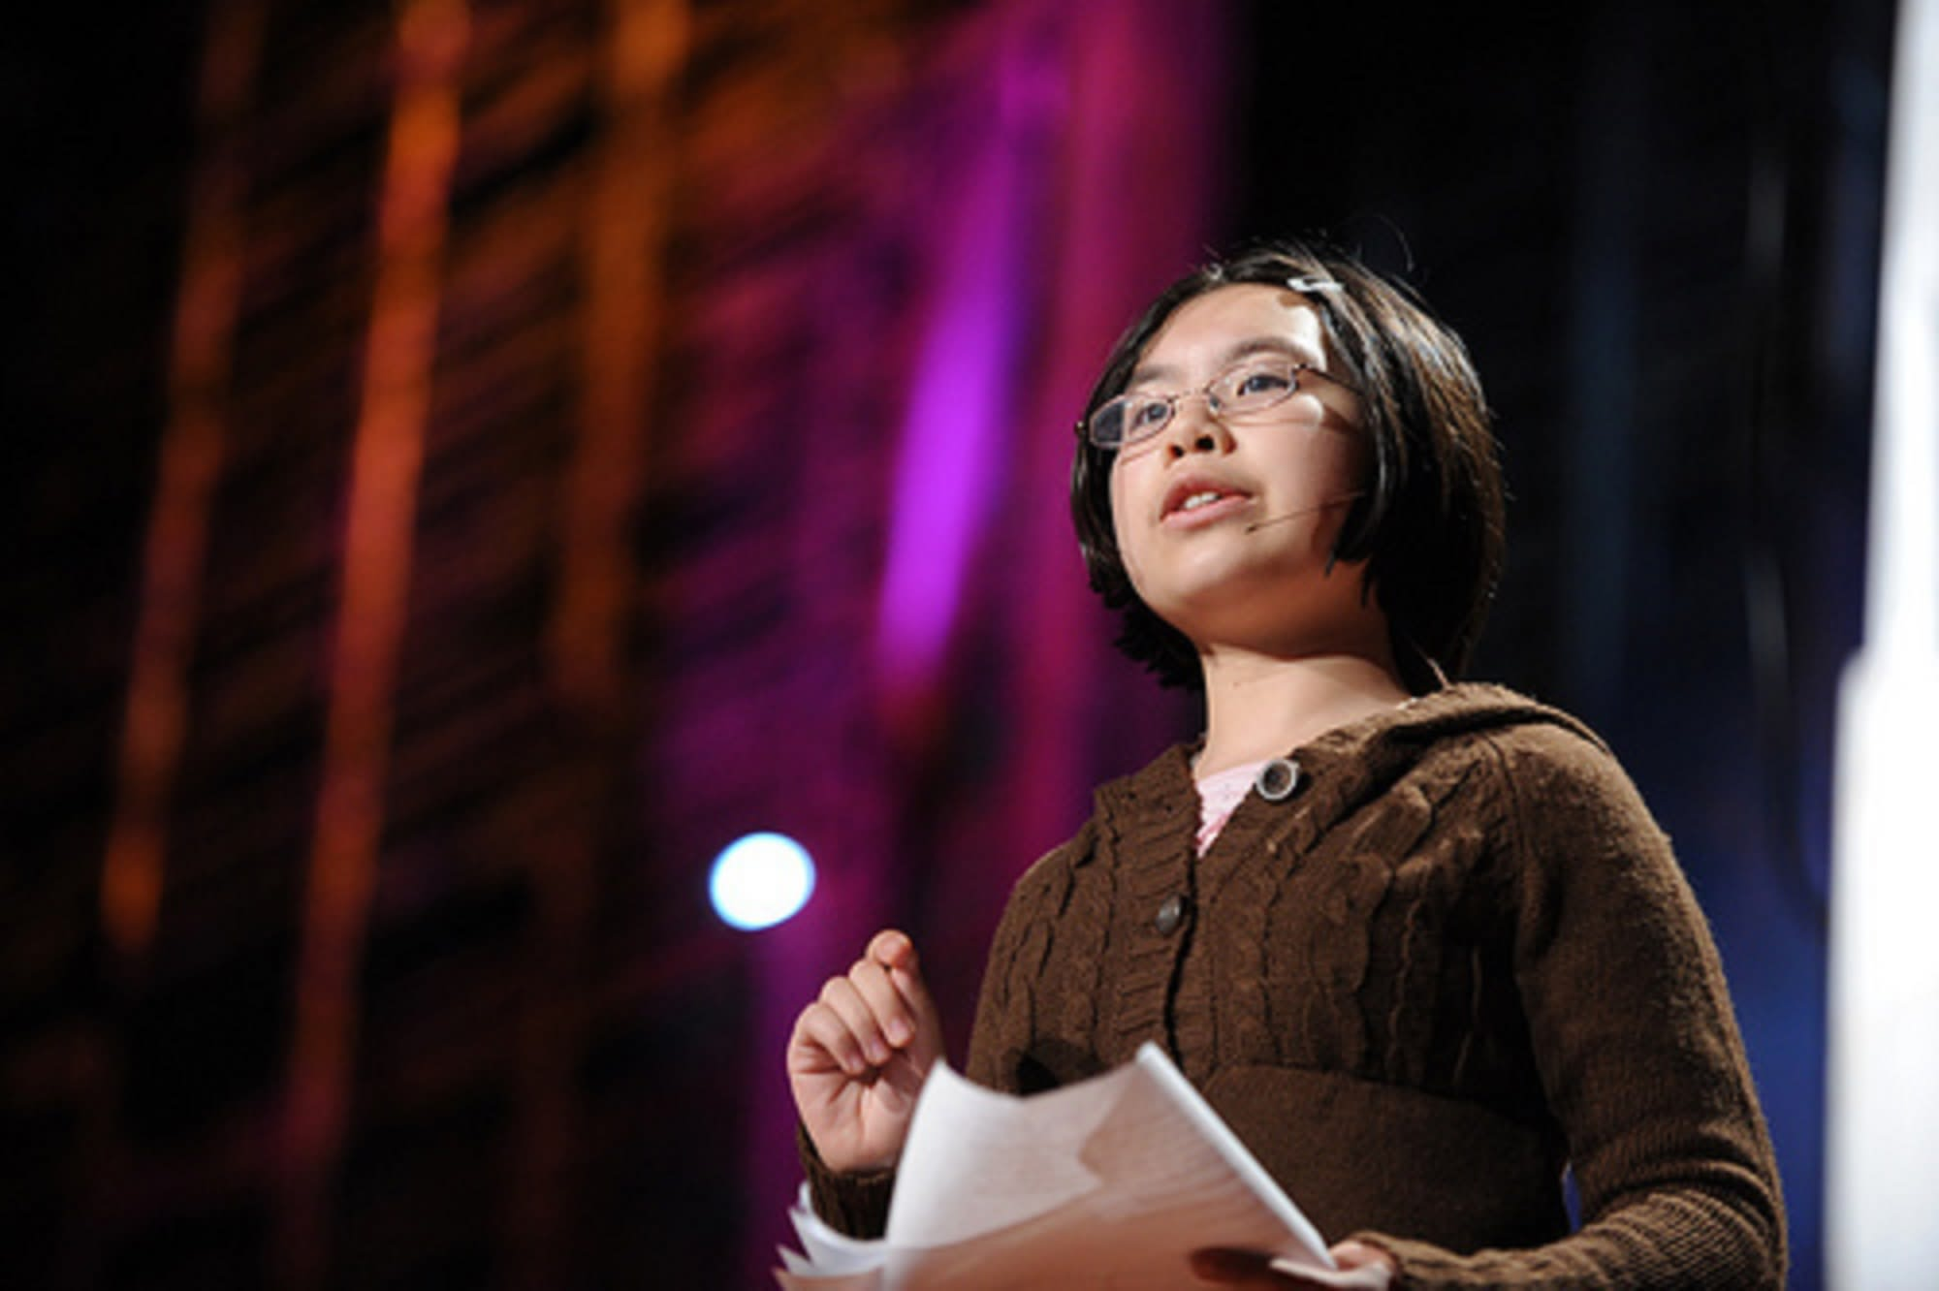  AWESOME PRIZES for 1st, 2nd, and 3rd place winners!!!  November 6th to December 16th  - Students will develop reading, writing, and public speaking skills.  - Everyone in the RHK8 community can participate.  3420 Julia Ave  Augusta, GA 30906  (706)796-4944

